การตั้งค่า How to configure and monitor the packet forwarder?

The configuration is achieved in 3 steps:

1.lorad configuration

2.lorafwd configuration

3.monitoring and auto-start configuration

1.lorad configuration

1. copy plan จาก /etc/lorad/PLATFORM where PLATFORM equal to ibts, wifc, wiis or fevo):

AS923-TH-SG-HK-TW.json

ไปที่ /etc/lorad/lorad.json

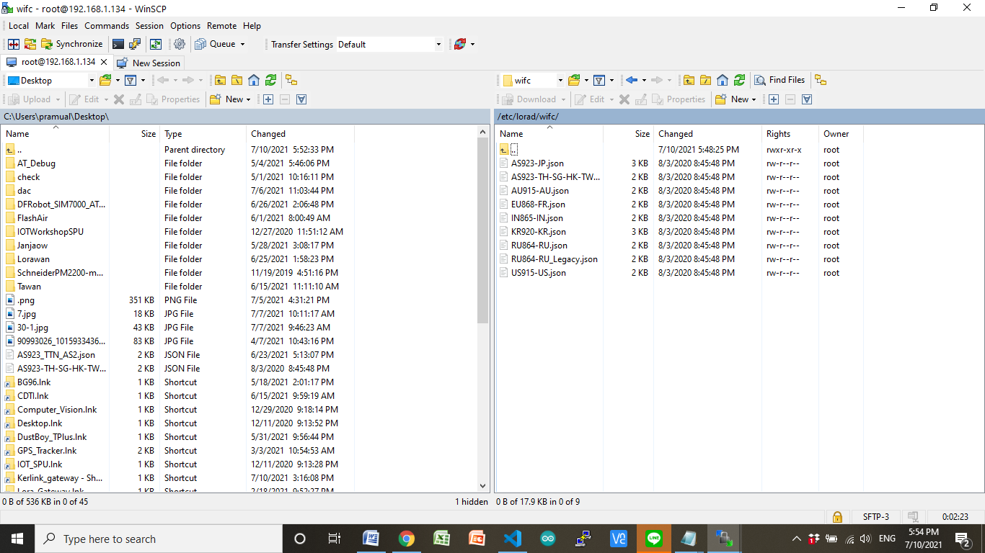

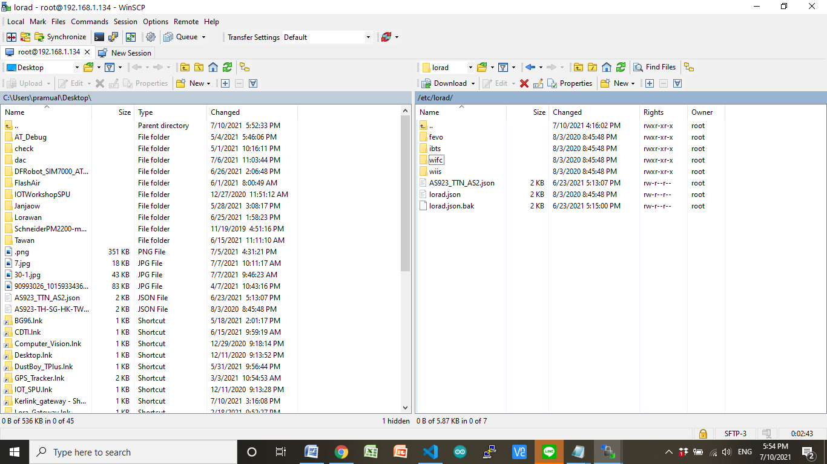

* Edit /etc/default/lorad and make sure that the CONFIGURATION_FILE ว่า ใช่

CONFIGURATION_FILE="/etc/lorad/lorad.json"

* Edit /etc/default/lorad and make sure that DISABLE_LORAD=“no”

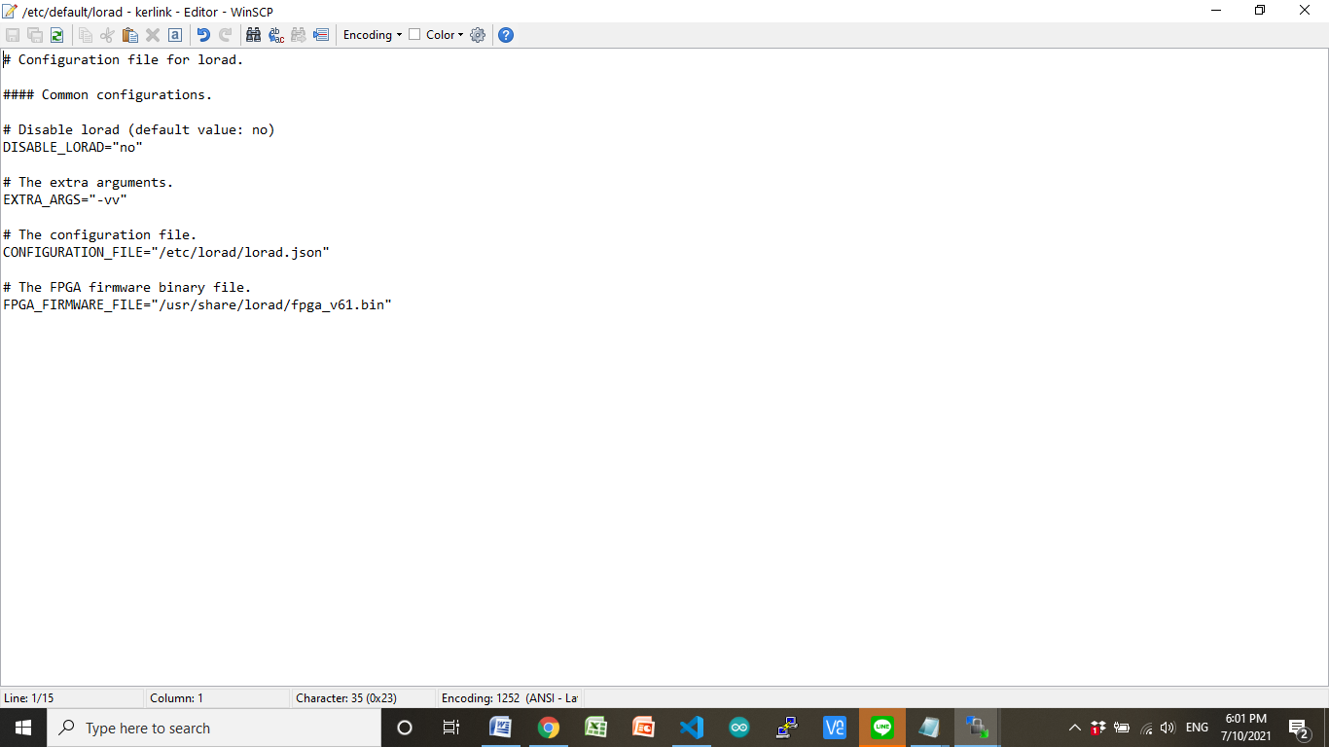

2.lorafwd configuration

The goal of the lorad configuration is to define the frequency plan that will be used to receive packets from the end-devices, to enable the LBT feature and to configure the class B beacons.

1. Edit /etc/default/lorafwd and make sure that DISABLE_LORAFWD=“no” is present in this file.

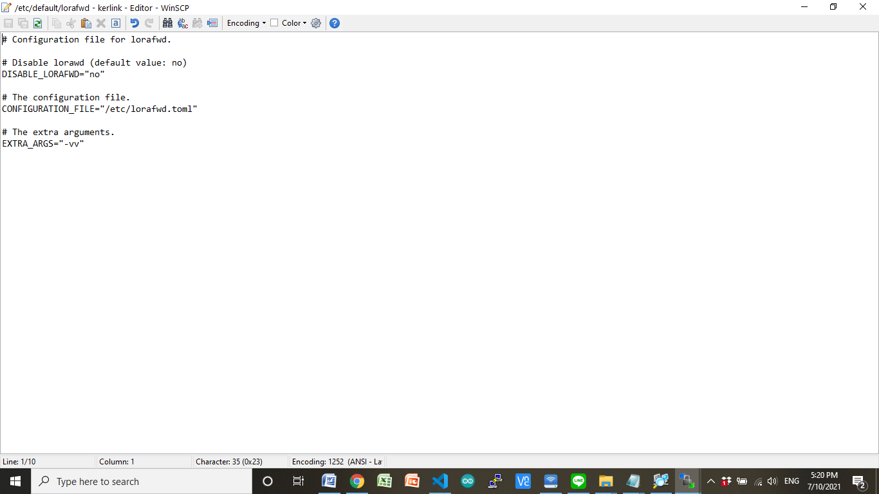

1. Edit /etc/lorafwd.toml. This configuration file is formatted using the TOML v0.5.0 language:

Hereunder are the keys that must be changed to chose your LNS:

gwmp.node = “localhost”: The address of the LNS.

gwmp.service.uplink = 1700: The uplink port of the LNS.

gwmp.service.downlink = 1700: The downlink port of the LNS.

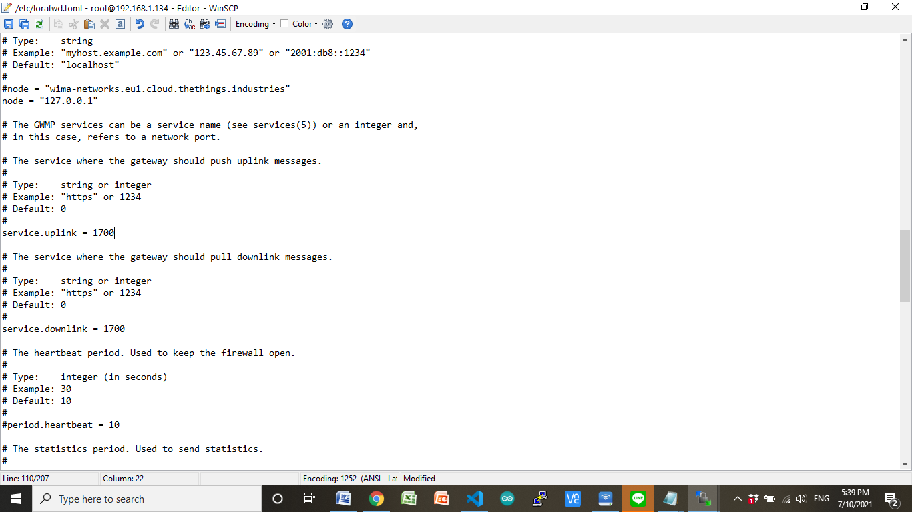

1. Monitoring and auto-start configuration

ติดตั้งในส่วนของ Chripstack บน Kerlink gateway

<https://www.chirpstack.io/gateway-bridge/gateway/kerlink/>

login gateway

Enable Kerlink CPF

klk_apps_config --activate-cpf